**Отзывы родителей учащихся 1-2 дежурных классов о питании детей**

[[](https://www.facebook.com/photo/?fbid=713199022890658&set=pcb.713198716224022&__cft__%5b0%5d=AZWPvA03tAA9XeigcTvuwmmEr1IIVEfZADJXTBFFiwiL9tZrTBEUBa8yyJtGgDyeMCfib3YLAlyzGydcJ15haw18u-BpcX1BZJZgCOm2XbB4bzMTngcGn2zCCu1axHFRU4A&__tn__=*bH-R)[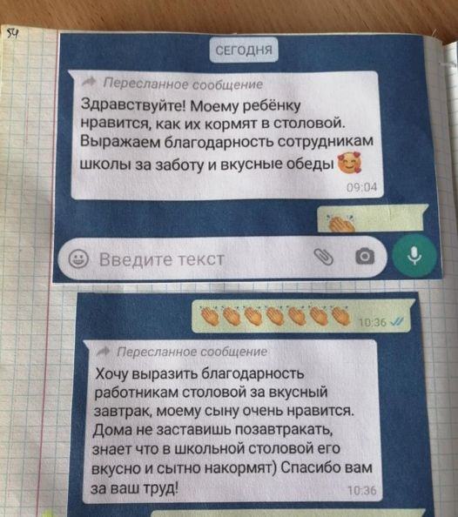](https://www.facebook.com/photo/?fbid=713199152890645&set=pcb.713198716224022&__cft__%5b0%5d=AZWPvA03tAA9XeigcTvuwmmEr1IIVEfZADJXTBFFiwiL9tZrTBEUBa8yyJtGgDyeMCfib3YLAlyzGydcJ15haw18u-BpcX1BZJZgCOm2XbB4bzMTngcGn2zCCu1axHFRU4A&__tn__=*bH-R)](https://www.facebook.com/photo/?fbid=713199152890645&set=pcb.713198716224022&__cft__%5b0%5d=AZWPvA03tAA9XeigcTvuwmmEr1IIVEfZADJXTBFFiwiL9tZrTBEUBa8yyJtGgDyeMCfib3YLAlyzGydcJ15haw18u-BpcX1BZJZgCOm2XbB4bzMTngcGn2zCCu1axHFRU4A&__tn__=*bH-R)

[[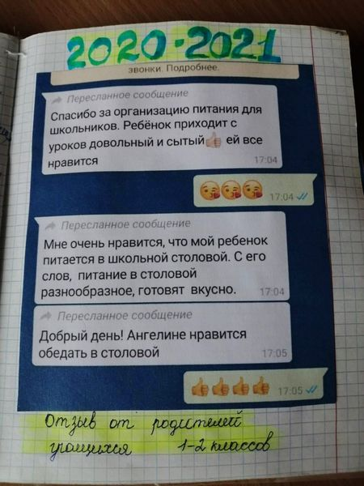](https://www.facebook.com/photo/?fbid=713199146223979&set=pcb.713198716224022&__cft__%5b0%5d=AZWPvA03tAA9XeigcTvuwmmEr1IIVEfZADJXTBFFiwiL9tZrTBEUBa8yyJtGgDyeMCfib3YLAlyzGydcJ15haw18u-BpcX1BZJZgCOm2XbB4bzMTngcGn2zCCu1axHFRU4A&__tn__=*bH-R)[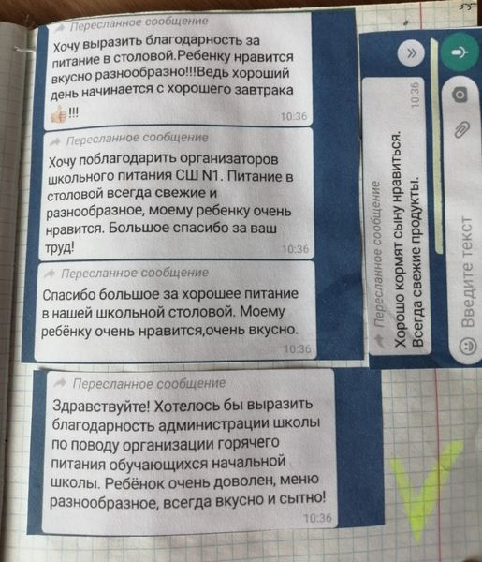](https://www.facebook.com/photo/?fbid=713199189557308&set=pcb.713198716224022&__cft__%5b0%5d=AZWPvA03tAA9XeigcTvuwmmEr1IIVEfZADJXTBFFiwiL9tZrTBEUBa8yyJtGgDyeMCfib3YLAlyzGydcJ15haw18u-BpcX1BZJZgCOm2XbB4bzMTngcGn2zCCu1axHFRU4A&__tn__=*bH-R)](https://www.facebook.com/photo/?fbid=713199146223979&set=pcb.713198716224022&__cft__%5b0%5d=AZWPvA03tAA9XeigcTvuwmmEr1IIVEfZADJXTBFFiwiL9tZrTBEUBa8yyJtGgDyeMCfib3YLAlyzGydcJ15haw18u-BpcX1BZJZgCOm2XbB4bzMTngcGn2zCCu1axHFRU4A&__tn__=*bH-R)