Дұрыс жауаптарды ағылшын тілі пәні мұғалімі Абдуллаева Айнур Канатхановнаның жеке электрондық поштасына жібересіздер.
abdullaeva_ainur@mail.ru
Grade 6

Task 1.
Underline the most suitable word in each sentence.
1 Different countries have different weather / weathers.
2 All areas of the skin are in fact covered in tiny hair / hairs.
3 We’ve looked at the menu and we’d all like chicken / chickens.
4 Jack is a millionaire and owns a lot of business / businesses.
5 Have you got a copy of the complete work / works of Dante?
6 None of the passengers had insured their baggage / baggages.
7 Students must pass their paper / papers to the front.
8 I’m afraid we can’t find cheap accommodation / accommodations for all of you.

Task 2. Read about a famous movie’ Life of Pi’ and do the task below.

Life of Pi
When Pi is 16, his family decides to close the zoo and move to Canada. They sell some of the animals to zoos in North America and the family takes the animals with them on a ship to Canada. On the way, there is a terrible storm and the ship sinks. Pi finds himself in a lifeboat with a hyena, zebra, orang-utan and a tiger. When he sees the animals, Pi is scared and he jumps into the ocean. Then he remembers there are sharks in the ocean and he climbs back into the lifeboat.
Pi and the tiger spend 227 days in the lifeboat. They live through terrible storms and are burnt by the Pacific sun. They are often hungry and ill. Sometimes, Pi is happy and hopeful, but sometimes he feels sad and lonely. Finally, they arrive at the coast of Mexico, but you will have to read the book to find out what happens in the end!

Circle True or False for these sentences.
1. | Pi helps his father look after the animals. | True | False
2. | Pi is scared when he sees the animals in the lifeboat. | True | False
3. | Pi fights with a big shark. | True | False
4. | At the end they land in the USA. | True | False

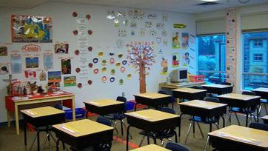
Task 3. Choose ONE of the topics below.

Topic 1. Our class

Think about your favourite class. Give some information about the subject and classmates.

- What is your favourite subject? Why?
- What does a person do to be good at school?
- Do you enjoy spending time with your classmates? Why?
- What clubs or sport activities do you like most at your school? Why?

