Theme: Refugees and natural disasters
Class: 7 A

Task1. Match the pictures (a-f) with the numbers 1-6

1 2 3
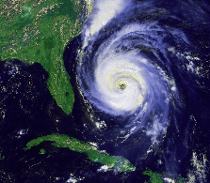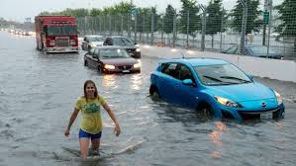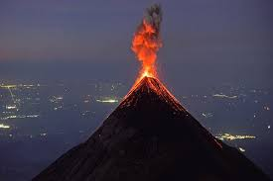

4 5 6
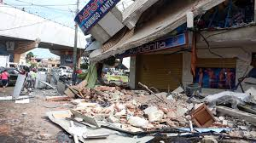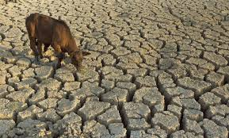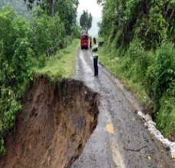

- Hurricane
- Earthquake
- Flood
- Landslide
- Drought
- Volcanic eruptions

Task 2. Read the text (scanning)
Learners read and understand the meaning of the text.
Underline the natural disasters and try to explain them with your own words.
What’s the worst natural disaster in your opinion?
‘Floods’ are opposite to ‘droughts’. A drought happens when there has been no rain for a long time. The land becomes too dry and it is impossible to grow any plants.
A ‘drought’ may result in a famine where there is not enough food for people and they start to starve (die from not eating).
A ‘hurricane’ (Atlantic Ocean), ‘typhoon’ (Pacific Ocean) or ‘tropical storm’ (Indian Ocean) is an intense thunderstorm which usually occurs in late summer. They result in strong winds and heavy rain.
‘Volcanic eruptions’ send red hot lava flowing. Lava is a type of liquid rock called magma.
‘Earthquakes’ occur when pressure is suddenly released which causes the ground to move and shake violently. If the earth quakes beneath water then the shock wave which reaches beaches and dry land causes huge waves travelling at high speed called ‘tsunamis’.
A ‘landslide’ happens when rocks and earth are water-laden from lots of rain and slide down.
Task 3. Activity: «Hot- air- balloon»
The pupils should speak about refugees and natural disasters by answering these questions.
- Who are the refugees?
- Why do the refugees move to another country?
- Some countries are not allowed them to enter the country why?

Descriptor:
Speaks on given topics and gives the best ideas.

