Irregular verbs (past simple)

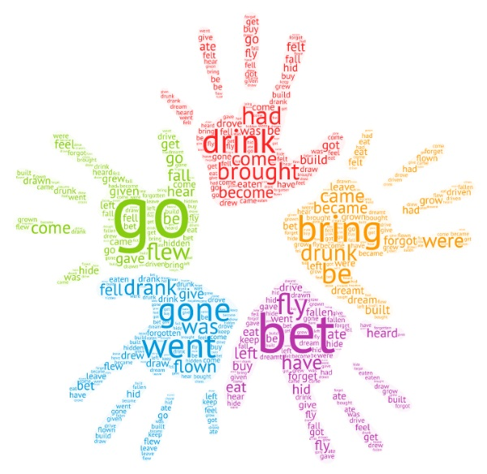
2) What are the past simple forms of the verbs given in the box? Put them in pair that rhyme.

Example: did - hid
1.__________________
2.__________________
3. __________________
4. __________________
5. __________________
6. __________________
7. ___________________

1) Write the base forms of the following verbs.
PresentPast
1.________froze
2.________hurt
3.________lent
4.________ bred
5.________stuck
6. _______lay
7. _______tore
8. _______threw
9. _______slept
10._______sought
11._______hung

fly / set / shake /
meet / fight / keep
send / take / buy
know / teach /
sleep / catch / go

3) Find the past tense of the verbs given below in the word search.
strike / lay / wear / bend / kneel /bring / forgive / fly / sell / understand / think / leap / rise / drink / choose

s | a | w | t | h | o | u | g | h | t | r
k | t | o | y | o | g | j | v | j | o | n
n | b | r | o | u | g | h | t | s | g | h
a | i | e | u | p | e | b | e | m | i | e
r | p | h | d | c | s | e | y | o | j | v
d | r | l | o | a | k | n | e | l | t | a
e | o | e | v | r | e | t | r | e | a | g
s | f | l | e | w | h | m | s | a | p | r
o | s | a | n | i | g | a | n | p | j | o
v  4) Complete the sentences with the correct form of the verbs.  1. Mary __________ the keys on the table and ________ the room ( lay / leave).  2. When John ___________ the news and he just __________ of joy ( hear / leap).  3. The wind ___________ fiercely last night (blow).  4. Ann __________ the gas and ___________ to cook the dinner (light / begin).  5. We ___________ long and hard but _______________ no answer (seek / find).  6. Ted couldn’t do that. His parents absolutely _____________________ (forbid).  7. The air __________________ my cheeks like fire (sting).  8. Jane ___________ the soup all over the table (upset).  9. The band ____________ seven years ago (split).  10. The swimmer was ____________________ away by the current (sweep).  11. At last, she couldn’t control herself and ___________ out laughing (burst).  12. They____________ blue uniforms and queer little caps (wear) | y | i | c | h | o | s | e | t | i | f
u | n | d | e | r | s | t | o | o | d | m

5) Unscramble the underlined irregular verbs.
1. I resow I wouldn't tell anyone right now.
2. Bright stars nehos out here and there in the sky.
3. She said she vegoraf her brother, and she was trying to.
4. The dress knashr when I washed it.
5. Sorry, I somokit you for someone else.
6. A slow, cold smile drapes across his face.
7. She tramed of future glory as an Olympic champion.

6) Choose the odd-one-out.

1. split spread drink burst
2. cost create come cast
3. hide hold kneel hang
4. tear draw wear bear
5. awake strike break speak

KEY

Ex. 1) 1 freeze 2 hurt 3 lend 4 breed 5 stick 6 lie 7 tear
8 throw 9 sleep 10 seek 11 hang

Ex. 2) 1 flew – knew 2 set – met 3 shook – took 4 fought – bought
5 kept – slept 6 sent – went 7 taught - caught

Ex. 4) 1 laid / left 2 heard / leapt 3 blew
4 lit / began 5 sought / found 6 forbade 7 stung Ex. 3)
8 upset 9 split 10 swept 11 burst
s |  | w | t | h | o | u | g | h | t | r
k | t | o |  |  |  |  |  |  | o
n | b | r | o | u | g | h | t | s
a |  | e | u |  |  | b | e |  |  | e
r |  |  | d | c |  | e |  |  |  | v
d |  | l |  |  | k | n | e | l | t | a
 | o |  |  |  |  | t |  | e |  | g
s | f | l | e | w |  |  |  | a |  | r
 |  | a |  |  |  |  |  | p |  | o
 |  | i | c | h | o | s | e | t |  | f
u | n | d | e | r | s | t | o | o | d

Ex. 5)
1 swore 2 shone 3 forgave 4 shrank 5 mistook 6 spread 7 dreamt

Ex. 6)
1 DRINK (split=split; spread=spread; burst=burst, but drink – drank)
2 CREATE is a regular verb
3 KNEEL (all the other verbs begin with letter H)
4 DRAW (tear-tore; wear-wore; bear-bore, but draw-drew)
5 STRIKE (awake-awoke; break-broke; speak-spoke, but strike-struck)

