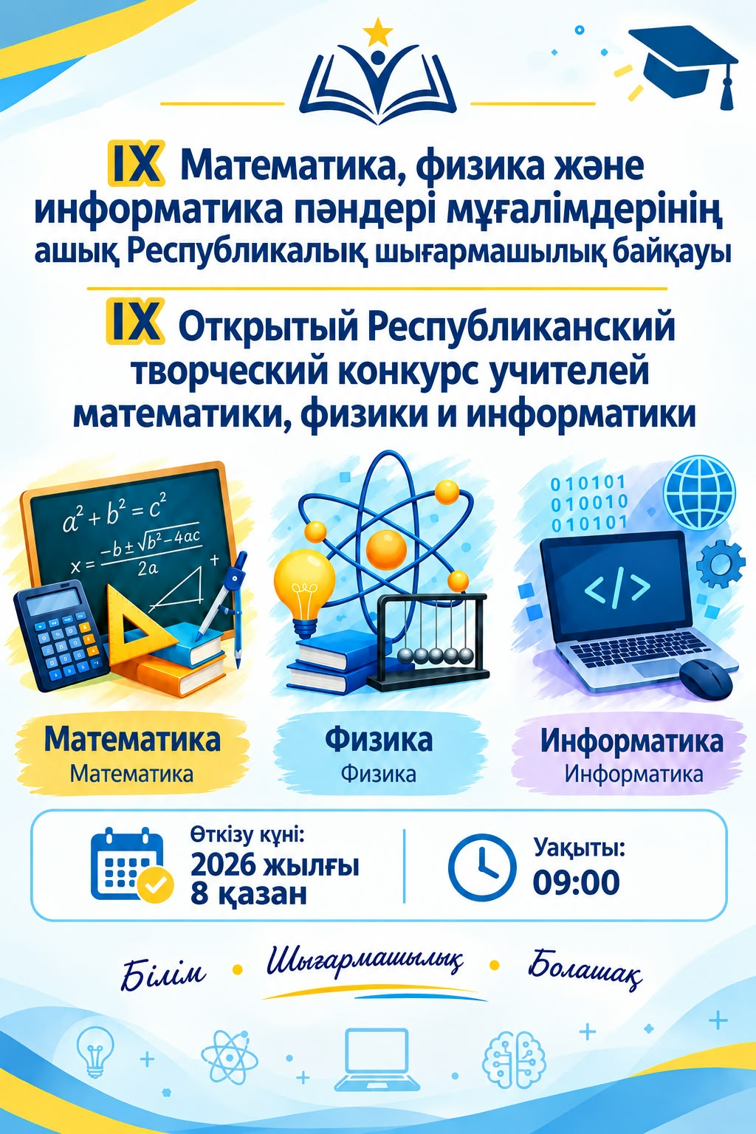

https://youtube.com/shorts/h01jneio-WM?si=gXW15zhkixJWRnkr

