Information of the school №9 on the training "Parents' contribution to the upbringing of children"
to create favorable conditions for the pupil in the family
On November 29, 2017, parents conducted a training course entitled "Parents' contribution to the upbringing of children".
Purpose: to show the relationship between the development of the child, the development of the personality and methods of education.

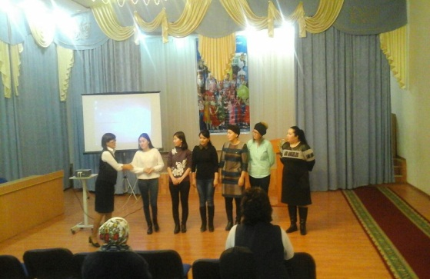
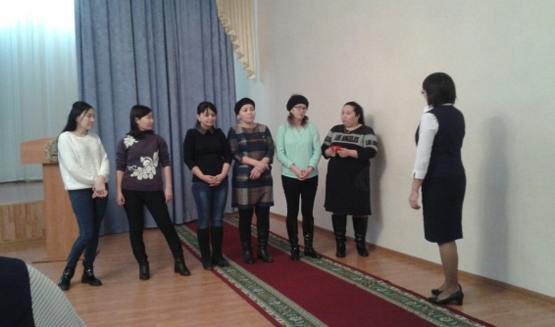

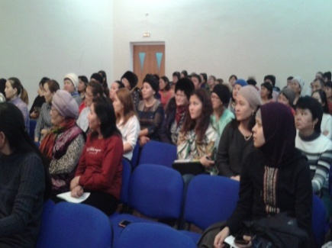
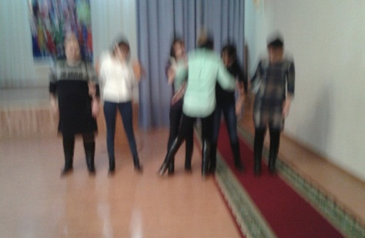
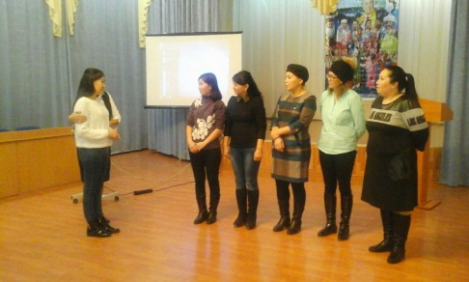

Психолог: :Есжанова.Г

